**Resume**

**Name** **:** A. Abisha 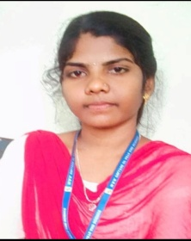

**Emil id :** abiahaabi149@gmail.com

**Mobile number:** 8438536103

**Addresss :** North street,

Nattarmangalam,

Kattumannar koil (TK),

Cuddalore (district),

608 301.

**Objective:**

To be a successful and to work for an organization with full zeal and aiming at not only authority’s satisfaction bull also over all personal development.

**Personal profile:**

**Name :** A. Abisha

**Father name :** N.Arivazhagan

**Date of birth :** 06.10.2003

**Gender :** Female

**Nationality :** Indian

**Religion :** Hindu

**Language known :** Tamil, English

**Permanent address :** North street,

Nattarmangalam,

Kattumannar koil (TK),

Cuddalore (district),

608 301.